BÀI TẬP THỰC HÀNH
Môn TKPMHĐT
---
Bài thực hành số 03: Sequence Diagrams and Communication diagrams

- Vẽ lược đồ sequence dưới đây

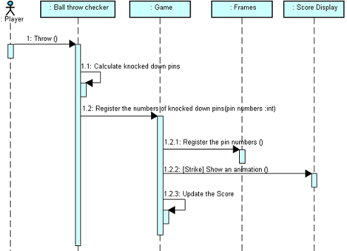

- Lập lược đồ sequence và communication cho các bài tập đã làm giờ lý thuyết.

- Đọc hiểu yêu cầu bài sau, sau đó thực hành trên máy các lược đồ bên dưới:

System Description

Customers
The customer database will store a customer’s personal information, such as address, phone number, name, and age. In addition to this, a list of medical conditions could be stored. This would be used to store such things as ‘High Blood Pressure’, ‘Asthma’, ‘Osteo-arthritis’ etc. A special medical condition might be to store a list of medical allergies. For example, if a customer is allergic to penicillin, it is important that a pharmacy not sell penicillin to the customer. It might be useful to store the list of allergies (to drugs) separately from their other medical conditions. Presumably, the customer could be taking drugs regularly to treat these conditions. A customer might also be taking drugs for unlisted conditions, such as ‘Aspirin’ for a headache. Your system must also record this information for each of its customers. Information about these drugs is listed in the following section.

Drugs
Pharmacies usually sell two kinds of drugs, non-prescription and prescription drugs. A drug may require a prescription by a qualified doctor for many reasons. These reasons include possible conflicts with other drugs, allergic reactions, or possible misuse or over-use of the drug. A customer should be prevented from acquiring a drug when he/she does not have a prescription, the drug conflicts with another drug being used by that customer, or the customer is allergic to the drug.
You may assume that non-prescription drugs do not have a significant possibility of conflicting with one another, causing dangerous side effects. However, it is possible that a prescription drug could conflict with a non-prescription drug. Since non-prescription drugs can be purchased at the cashier, or at another location, this should be monitored when the conflicting prescription drug is purchased.
Usually a drug, prescription and non-prescription alike, will contain several pieces of information on their packaging by Canadian law. One bit of information is a list of medical ingredients. For example, some headache medication may contain ‘Acetaminophen’ and ‘Caffeine’ to relieve headaches. A drug may also contain a list of non-medical ingredients, such as ‘Fructose’ (a type of sugar) to make it taste better in the case of many cough medicines. Ingredients, medicinal and non-medicinal, should contain both an ingredient name, and an amount, usually a mass. For example, a headache medicine may contain the ingredient ‘Acetaminophen’ with quantity ‘30mg’.
Since drugs are sold to customers, they usually include a brand name, such as ‘Advil’. They also typically contain directions, describing how to use the product. For example, they will describe how much to take and how often (dosage). It may also describe what type of drug the product is, such as capsule, cream, or liquid. Usually, they will list the conditions that are treatable with the product as well. For example, a cough medicine may treat ‘cough due to colds’, ‘nasal congestion’, etc.
In addition, prescription drugs in particular may contain a warning message. They may also contain a list of side effects that may result from using the product. It may also be desirable for your system to record the name and phone number of the doctor who prescribed the drug to the customer. If a customer comes in complaining of side effects, the doctor could be contacted.

Assignment Requirements
- Draw a complete class diagram describing all classes in the system, as well as the static relationships between these classes. Use a single diagram to illustrate your class relationships.
- Draw a sequence diagram describing the operation of a customer purchasing a prescription drug from the pharmacist. You can create new operations for the different classes, as long as they do something relatively trivial, and the name reflects the exact operation that is to be performed.
- Draw a collaboration diagram for the same operation.

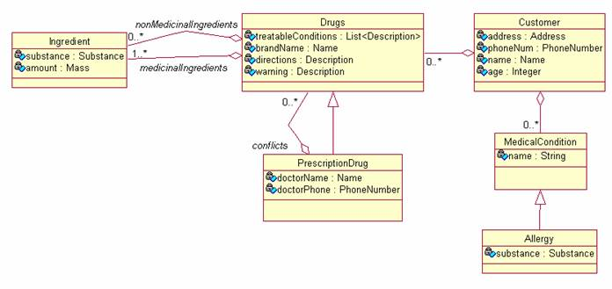

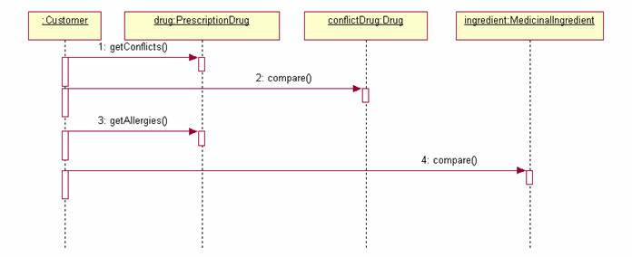
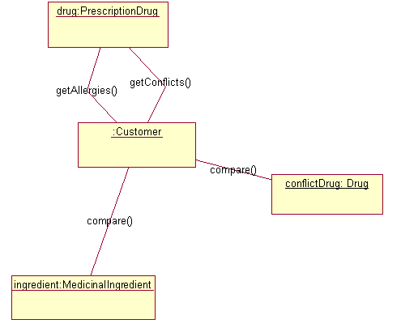

- Đọc mã nguồn của đoạn dưới đây, sau đó vẽ lược đồ Sequence

Given the Java code below, write a sequence diagram for the method processRegistration. Assume the method is called by the actor Registrar.

public class RegistrationModule {
private RegistrationDatabase regDB = ...;

public boolean processRegistration(String firstName,
String lastName, String address,
String email) {
if (regDB.isEmailAddressUnique(email)) {
RegData data = new RegData();
data.setFirstName(firstName);
data.setLastName(lastName);
data.setAddress(address);
data.setEMailAddress(email);
regDB.addRegistration(data);
} else {
return false;
}
}
}

public class RegistrationDatabase {
public void addRegistration(RegData data) {
addEntry(data);
}

public boolean isEmailAddressUnique(String email) {
for (int i = 0; i < getNumberOfEntries(); i++) {
boolean equal = matchEmail(email, i);
if (equal) {
return false;
}
}
return true;
}

private addEntry(RegData data) {
// ... code omitted ...
}

private boolean matchEmail(String addr, int index) {
// ... code omitted ...
}

private int getNumberOfEntries() {
// ... code omitted ...
}
}
-HẾT BÀI 3-

